**1 Variational Autoencoder (Keras)**

Standard autoencoders learn to generate compact representations and reconstruct their inputs well, but asides from a few applications like denoising autoencoders, they are fairly limited. The fundamental problem with autoencoders, for generation, is that the latent space they convert their inputs to and where their encoded vectors lie, may not be continuous, or allow easy interpolation.

If the space has discontinuities and you sample/generate a variation from there, the decoder will simply generate an unrealistic output, because the decoder has no idea how to deal with that region of the latent space. During training, it never saw encoded vectors coming from that region of latent space.

**1.1 Network Architecture**

Variational Autoencoders (VAEs) have one fundamentally unique property that separates them from vanilla autoencoders, and it is this property that makes them so useful for generative modeling: their latent spaces are, by design,continuous, allowing easy random sampling and interpolation.

It achieves this by doing something that seems rather surprising at first: making its encoder not output an encoding vector of size*n,*rather, outputting two vectors of size n: a vector of means**, μ**, and another vector of standard deviations, **σ**.

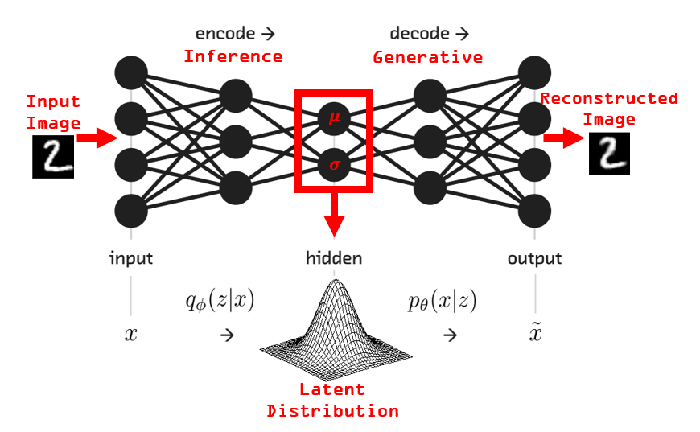

VAEs learn the parameters of the probability distribution that the data came from. These types of autoencoders have much in common with latent factor analysis. The encoder and decoder learn models that are in terms of underlying, unobserved latent variables. It's essentially an inference model and a generative model daisy-chained together.

VAEs learn about the distribution the inputs came from, we can sample from that distribution to generate novel data. VAEs can also be used to cluster data in useful ways.

**1.2 Code Implementation**

Encoder:

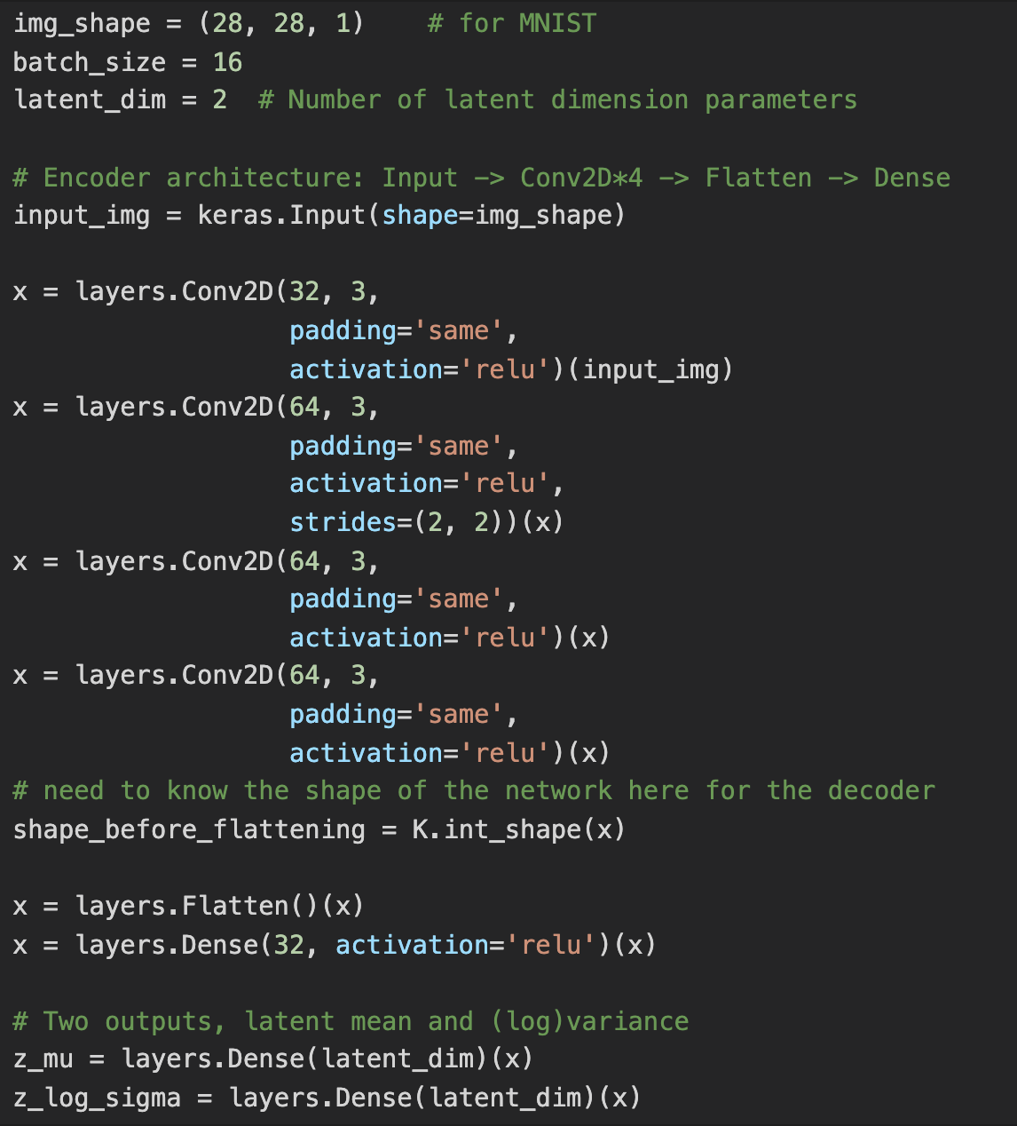

**Sampling layer:**

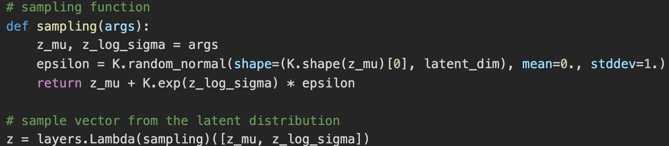

**Decoder:**

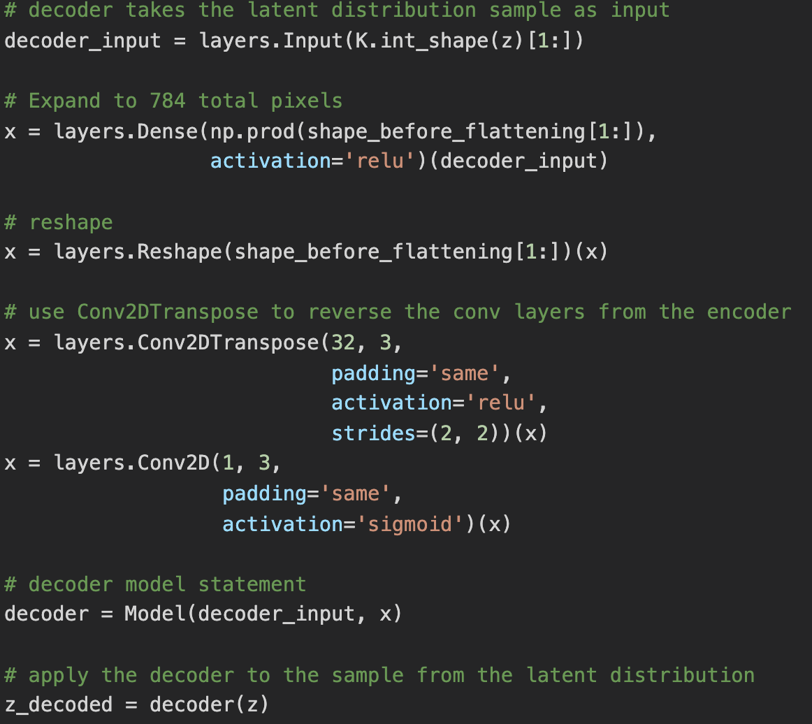

**I tried to run the code. However, there is an error shown as follows. I tried hours to fix this, including reinstall the anaconda, python, keras, and tensorflow. Yet, I still cannot run the code, and I don’t know why.**

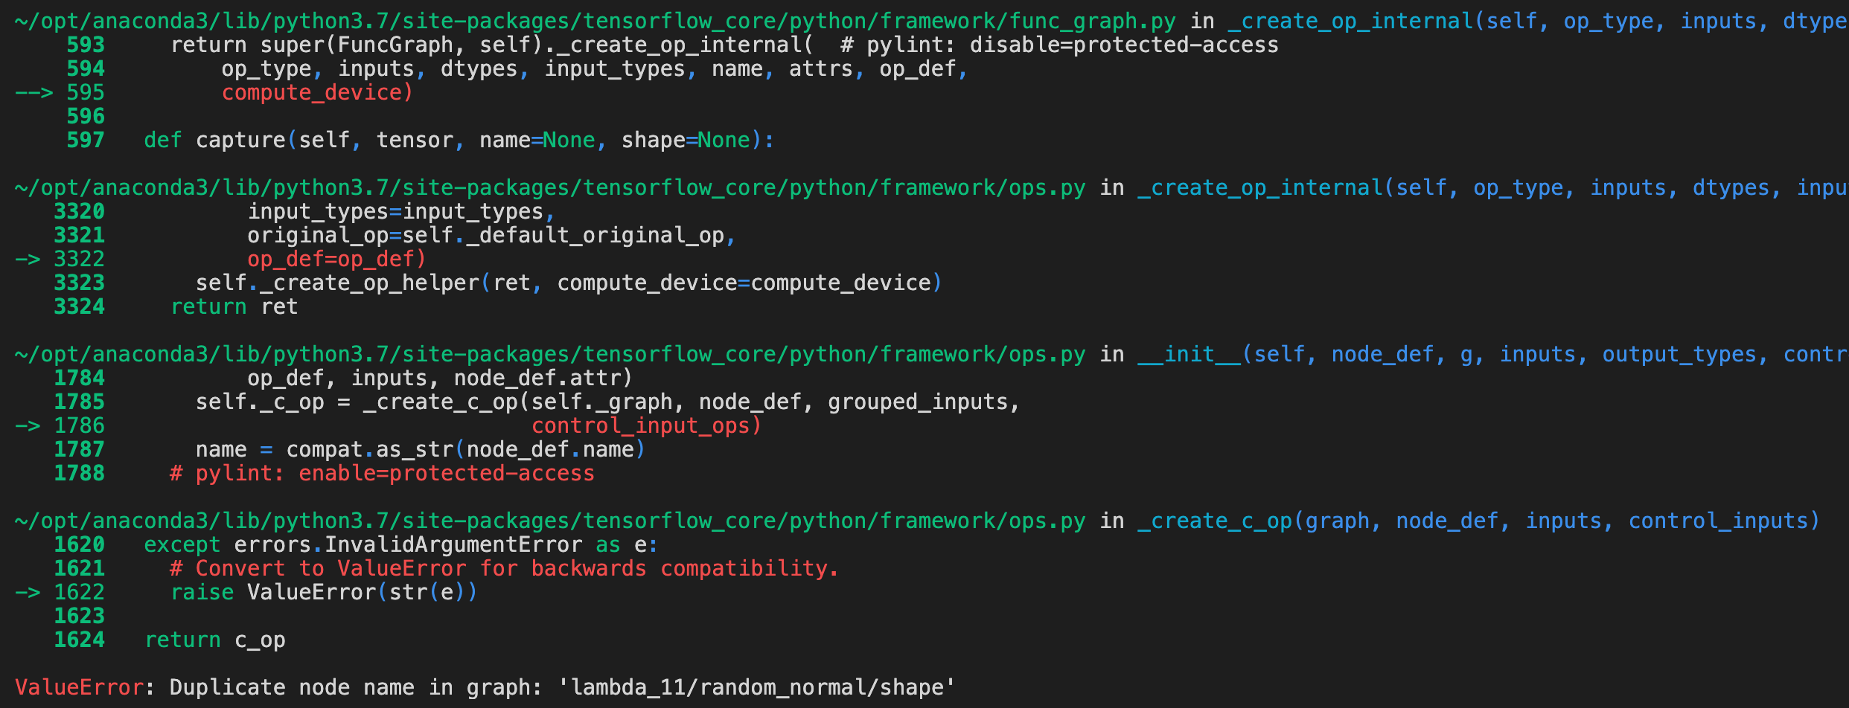

**1.3 Results**

**1.3.1 Clustering of digits in the latent space**

We can make predictions on the validation set using the encoder network. This has the effect of translating the images from the 784-dimensional input space into the 2-dimensional latent space. When we color-code those translated data points according to their known digit class, we can see how the digits cluster together.

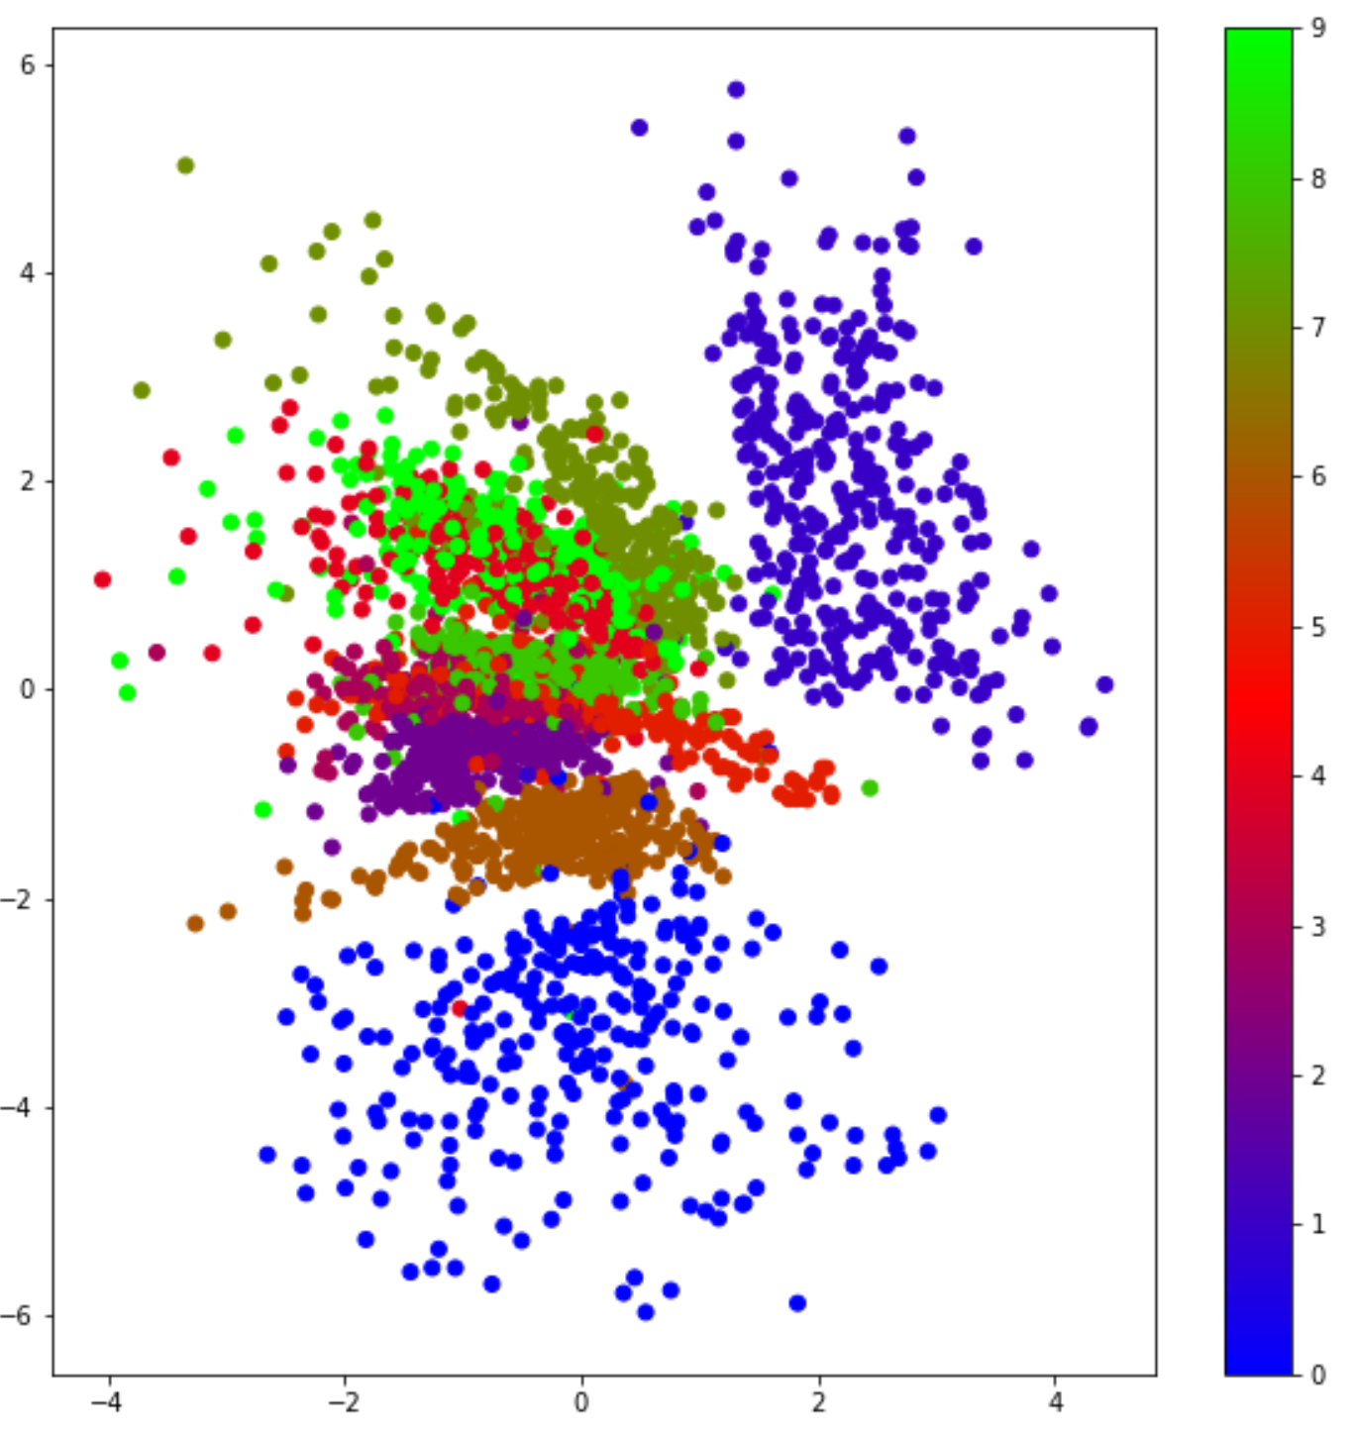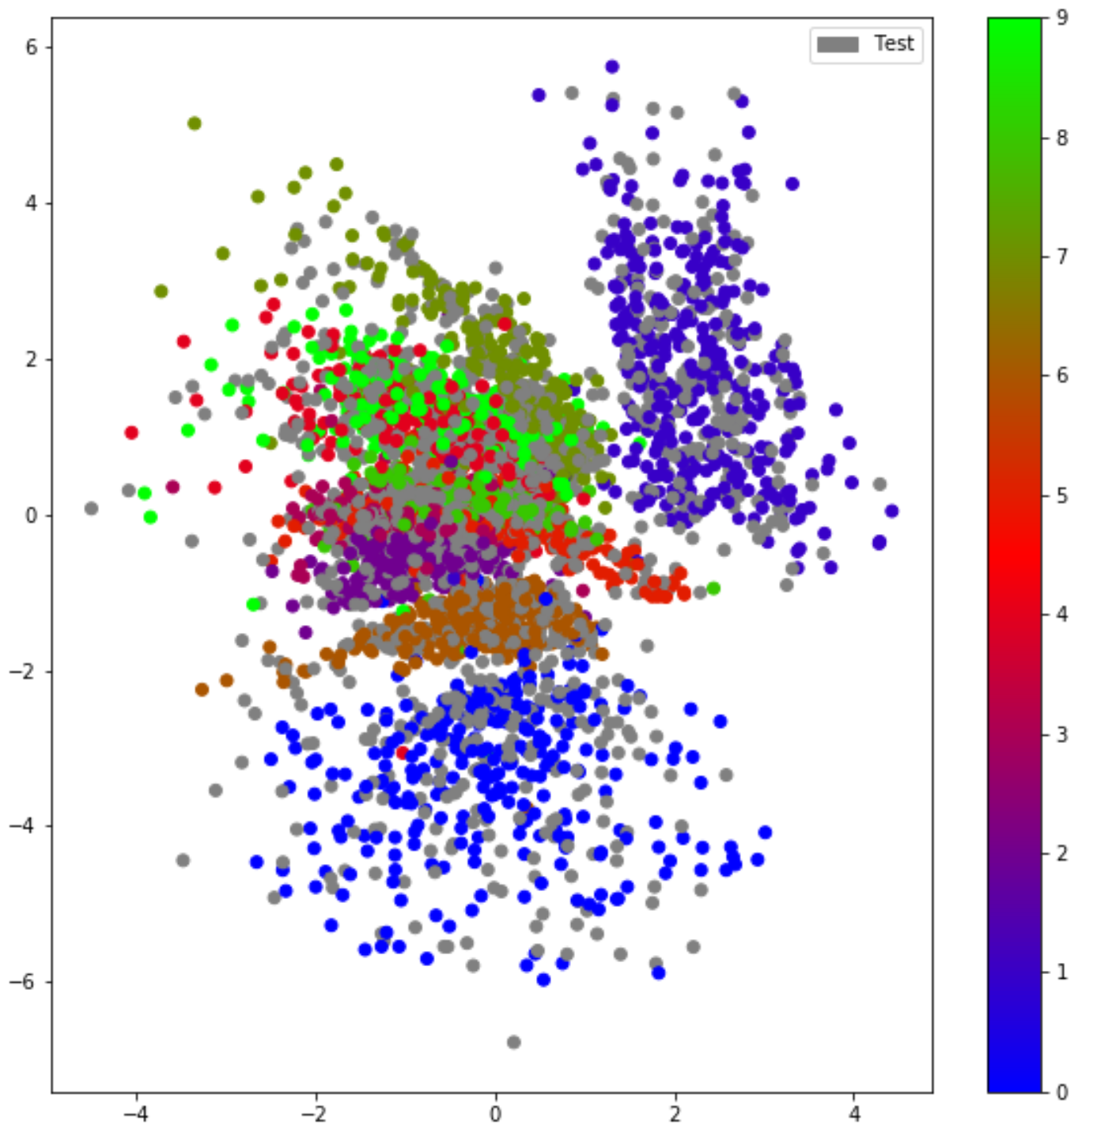

**1.3.2 Sample digits**

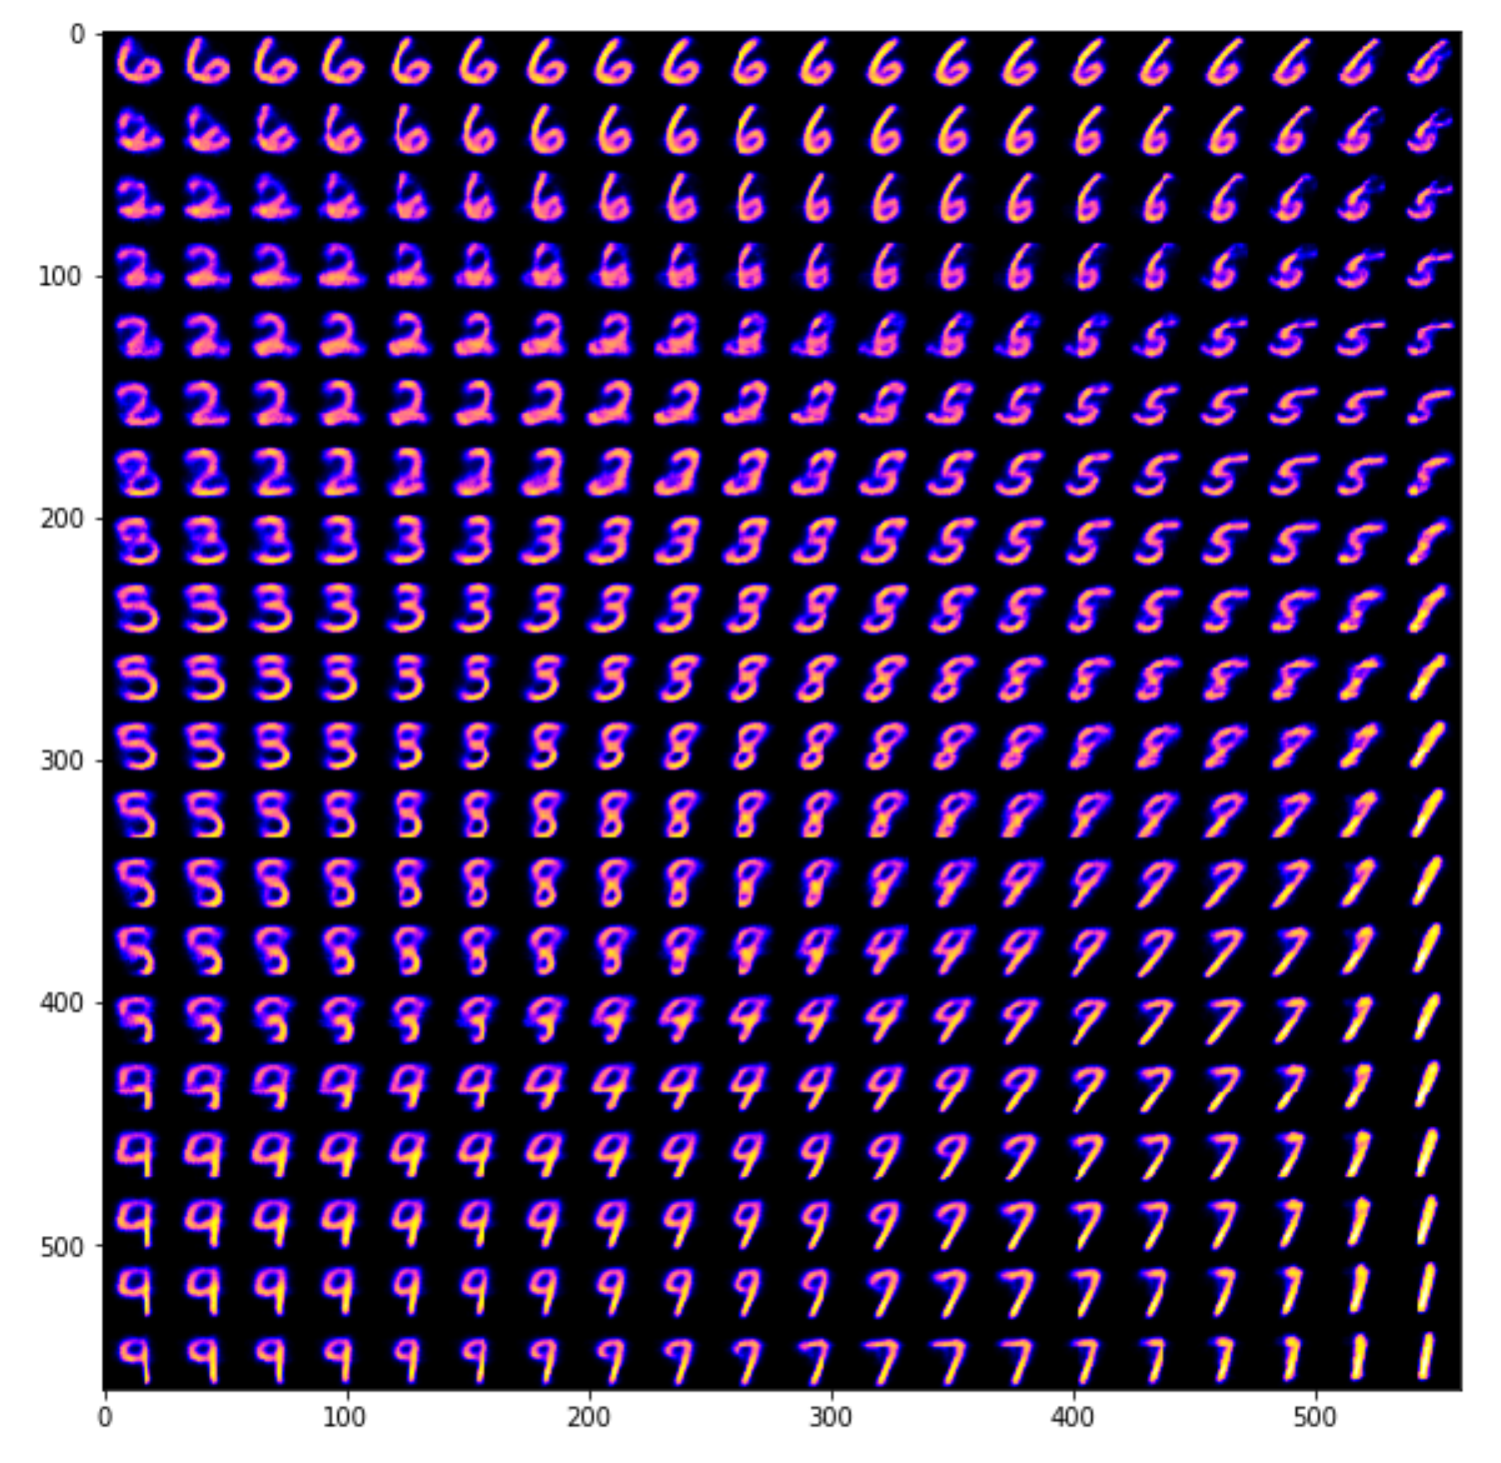

**2 Convolutional Autoencoder** **(TensorFlow)**

An autoencoder network is actually a pair of two connected networks, an encoder and a decoder. An encoder network takes in an input, and converts it into a smaller, dense representation, which the decoder network can use to convert it back to the original input. The goal of the autoencoder is to find a small representation of the input data.

I built a convolutional autoencoder in TensorFlow to compress the MNIST dataset. With autoencoders, I pass input data through an encoder that makes a compressed representation of the input. Then, this representation is passed through a decoder to reconstruct the input data.

**2.1** **Network Architecture**

The **encoder part** of the network is a typical convolutional pyramid. Each convolutional layer will be followed by a max-pooling layer to reduce the dimensions of the layers.

The **decoder part** of the network needs to convert from a narrow representation to a wide reconstructed image. The decoder takes the output of the encoder, generated form a 4x4x8 max-pool layer, as the input. The goal is to output a 28x28x1 image, so it needs to work back up from the narrow decoder input layer.

The structure of the convolutional autoencoder network is as follows.

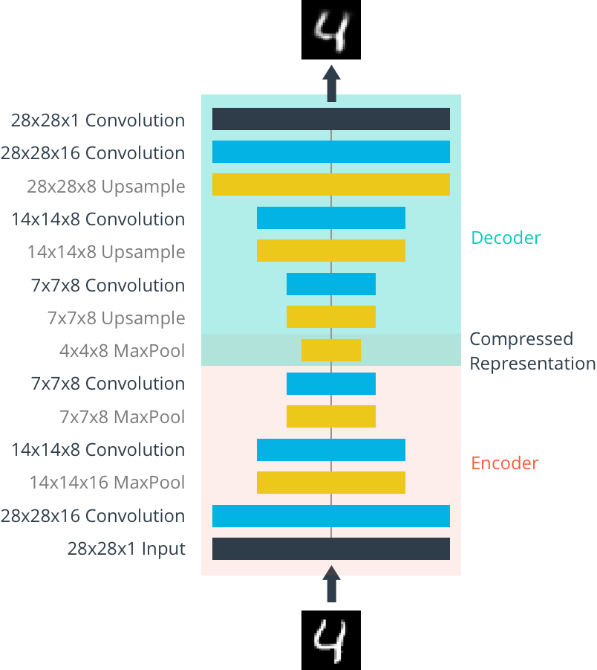

Here the original images have the size of 28x28 = 784, and the final encoder layer has the size of 4x4x8 = 128. So, the encoded vector is roughly 16% the size of the original image.

For convolutional layers, I used `tf.layers.conv2d`. I used `tf.layers.max_pooling2d` as the max-pool layers, to the reduce the width and height. A stride of 2 will reduce the size by a factor of 2.

The decoder has several "Upsample" layers, we can use transposed convolution layers to increase the width and height of the layers. They work almost exactly the same as convolutional layers, but in reverse. However, transposed convolution layers can lead to artifacts in the final images, such as checkerboard patterns. This is due to overlap in the kernels which can be avoided by setting the stride and kernel size equal.

In this article (<https://distill.pub/2016/deconv-checkerboard/>), the authors show that these checkerboard artifacts can be avoided by resizing the layers using nearest neighbor or bilinear interpolation (upsampling) followed by a convolutional layer. Therefore, instead of the transposed convolution layers, I used `tf.image.resize_images` followed by a convolution,

**2.2 Code Implementation**

The code is shown below:

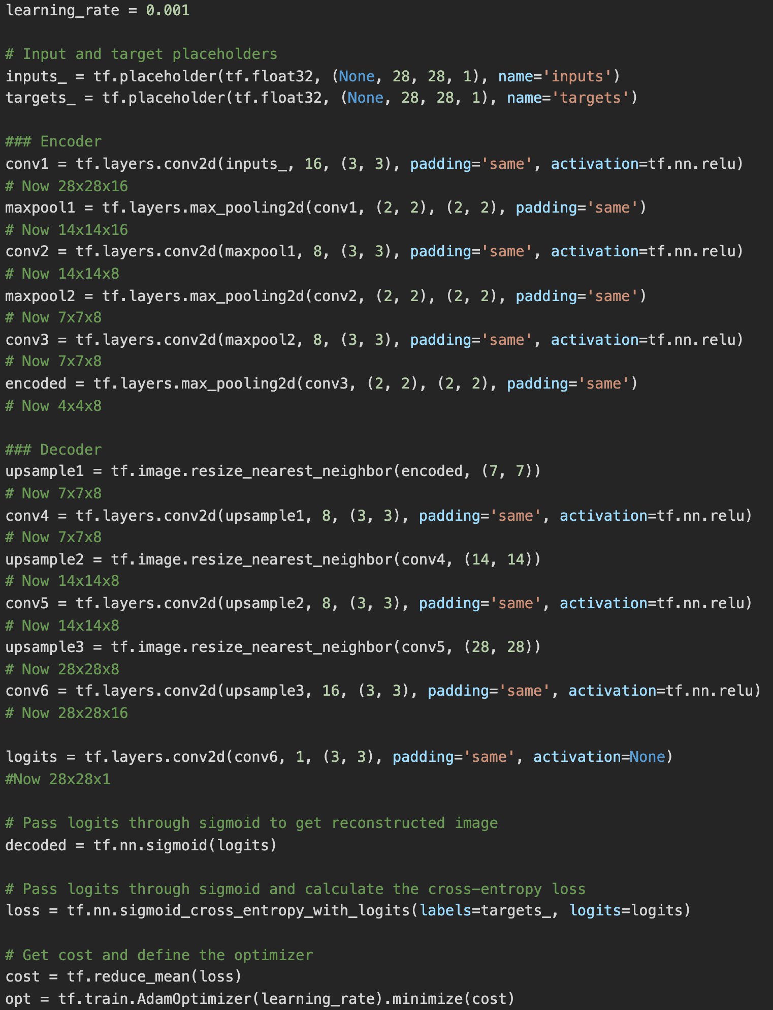

**2.3 Training & Evaluation**

In traning process, I pass the images into the network as 28x28x1 arrays.

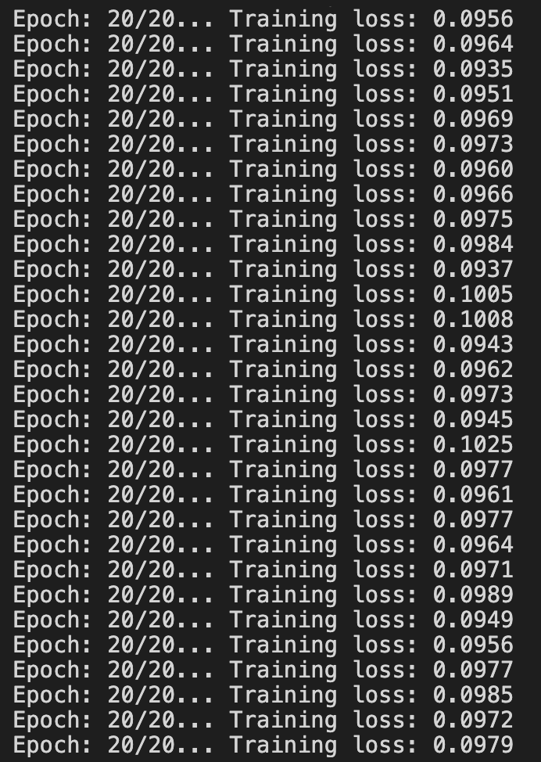

The output of the test set is as follows:

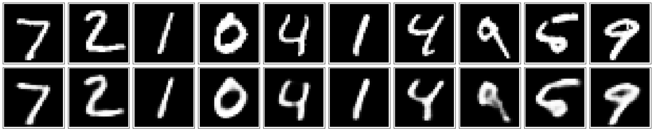

As shown above, the network can rebuild the images efficiently and precisely.

**2.4 Denoising**

Autoencoders can be used to denoise images quite successfully just by training the network on noisy images. I can create some the noisy images by adding Gaussian noise to the training images, then clipping the values to be between 0 and 1. I used noisy images as input and the original, clean images as targets. Here's an example of the noisy images I generated and the denoised images.

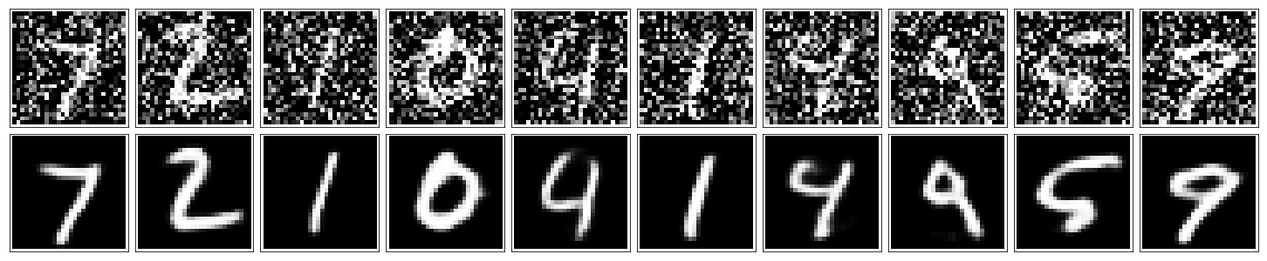

Since this is a harder problem for the network, I used deeper convolutional layers and more feature maps. I used 32-32-16 for the depths of the convolutional layers in the encoder, and the same depths going backward through the decoder.

The code is shown as follows:

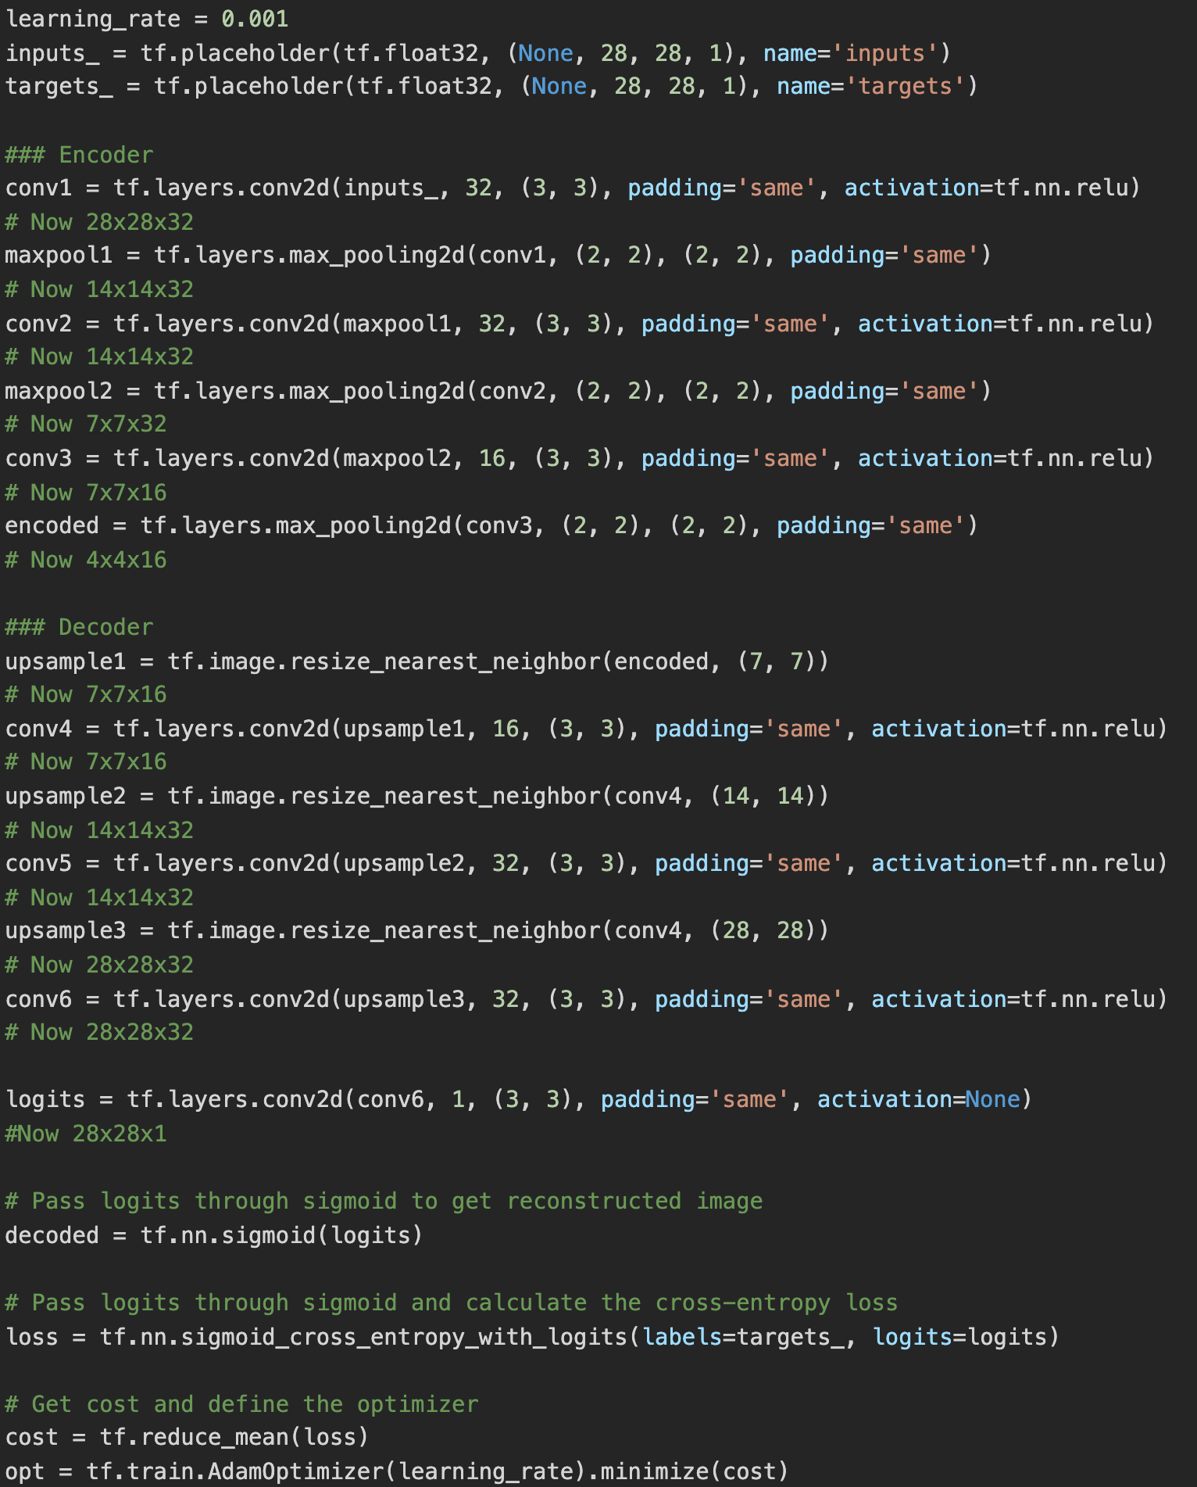

The result of the validation of the denoising is as below:

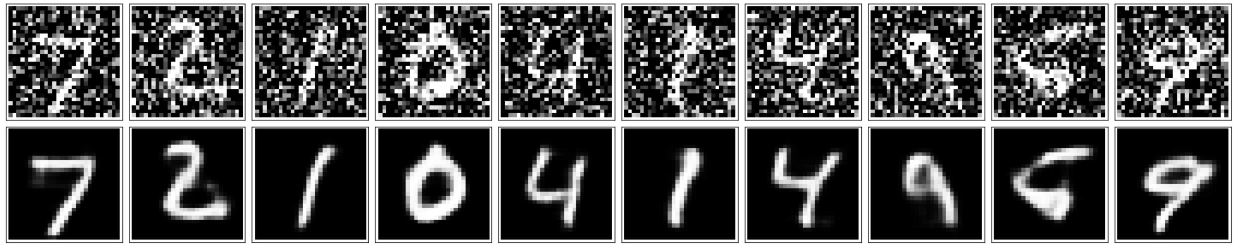

I added noise to the test images and passing them through the autoencoder. It does a suprisingly great job of removing the noise, even though it's sometimes difficult to tell what the original number is.

**3 Generative Adverserial Networks (TensorFlow)**

Generative adversarial networks (GANs) are algorithmic architectures that use two neural networks, pitting one against the other (thus the “adversarial”) in order to generate new, synthetic instances of data that can pass for real data. They are used widely in image generation, video generation and voice generation.

**3.1 Network Architecture**

One neural network, called the generator, generates new data instances, while the other, the discriminator, evaluates them for authenticity; i.e. the discriminator decides whether each instance of data that it reviews belongs to the actual training dataset or not.

Meanwhile, the generator is creating new, synthetic images that it passes to the discriminator. It does so in the hopes that they, too, will be deemed authentic, even though they are fake. The goal of the generator is to generate passable hand-written digits: to lie without being caught. The goal of the discriminator is to identify images coming from the generator as fake.

The steps a GAN takes:

* The generator takes in random numbers and returns an image.
* This generated image is fed into the discriminator alongside a stream of images taken from the actual, ground-truth dataset.
* The discriminator takes in both real and fake images and returns probabilities, a number between 0 and 1, with 1 representing a prediction of authenticity and 0 representing fake.

Here is the architecture graph I understand:

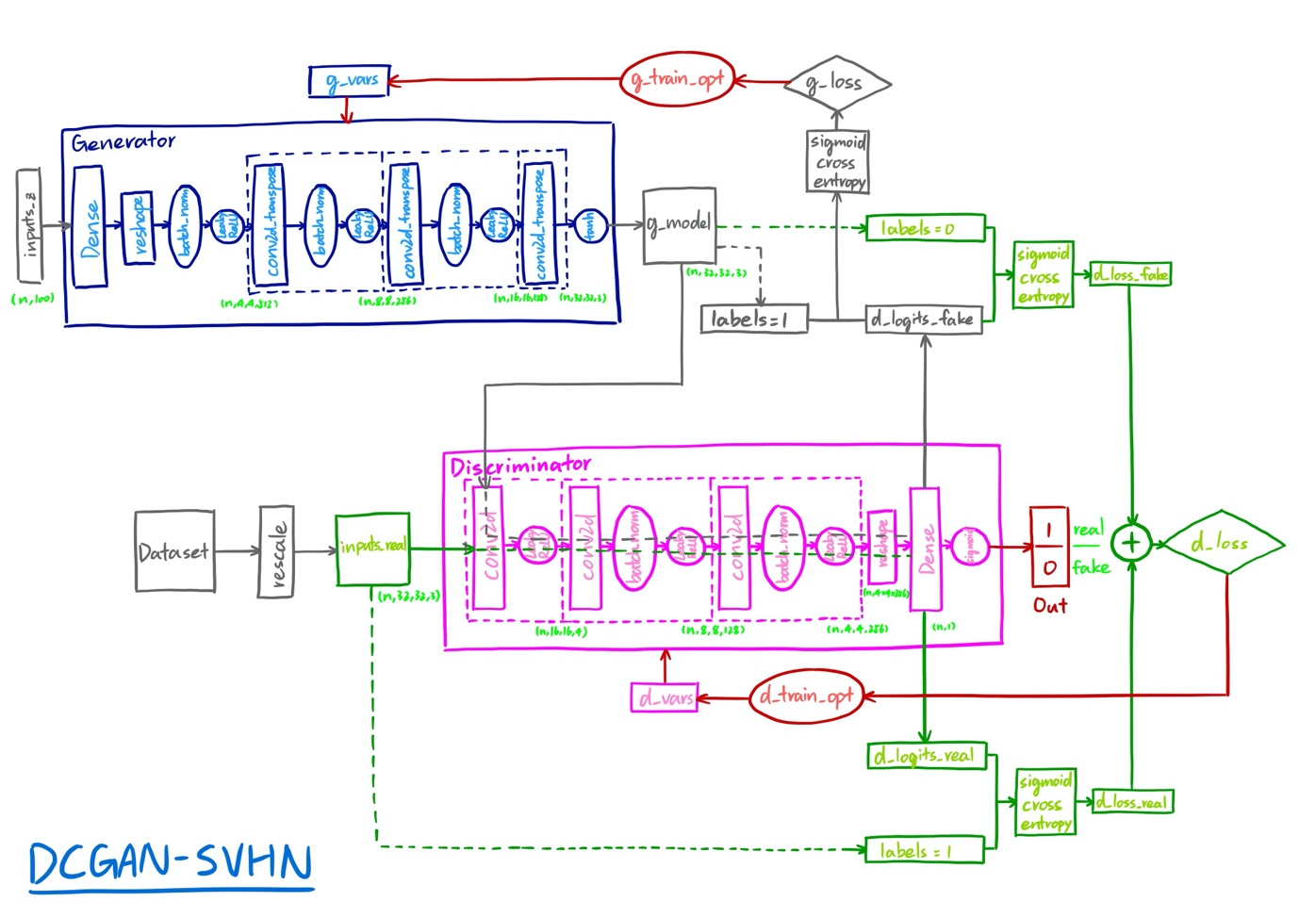

The update process is as folliwing:

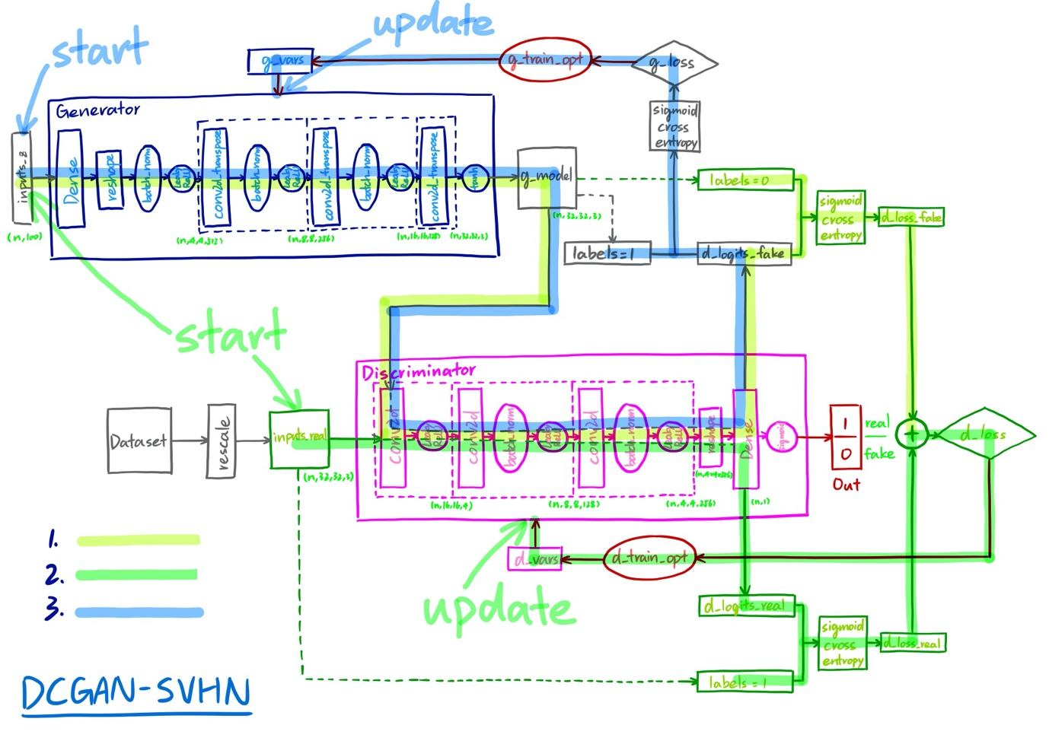

**3.2 Code Implementation**

I implemented the GAN in TensorFlow because I’m more familiar with it than PyTorch.

Generator:

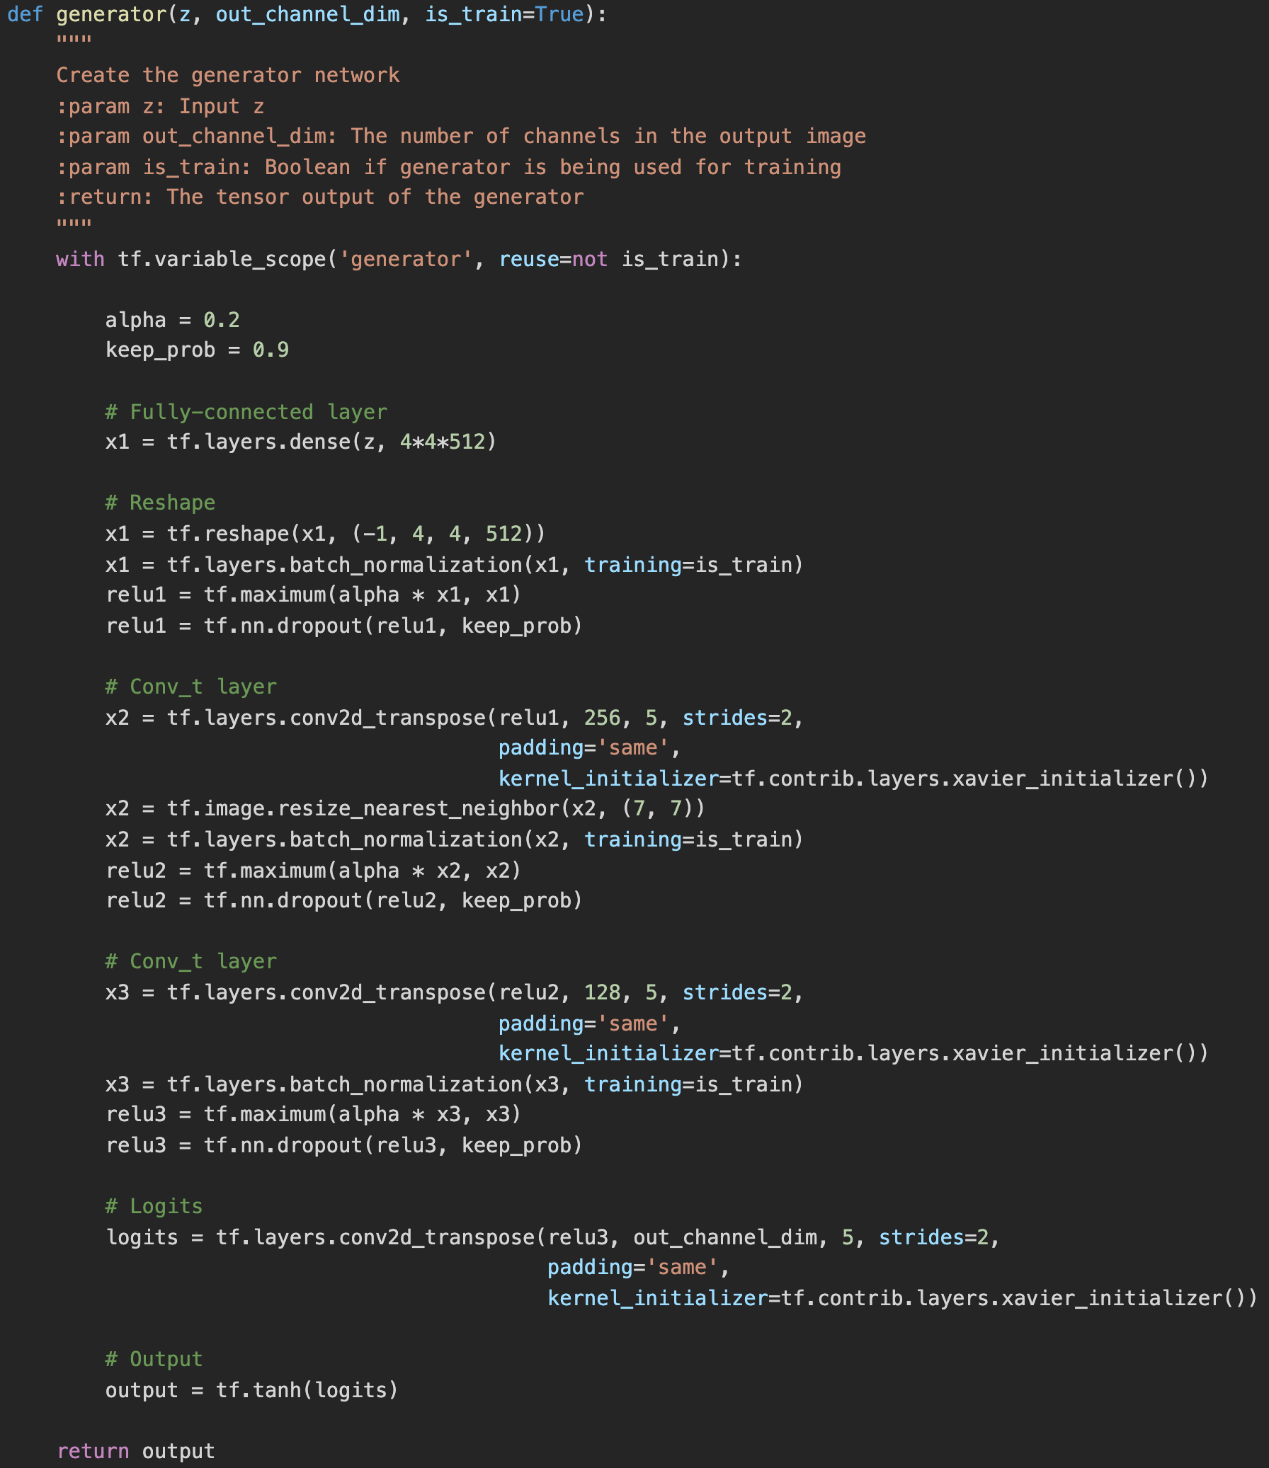

Discriminator:

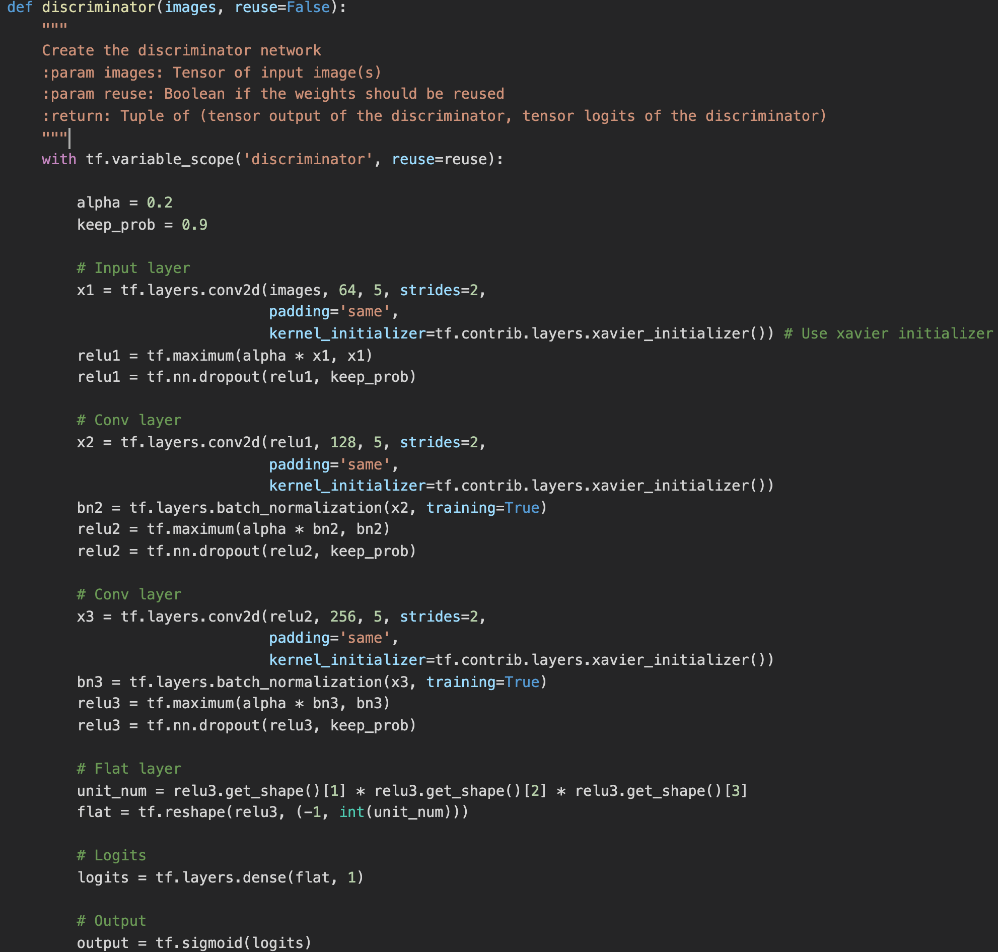

Loss:

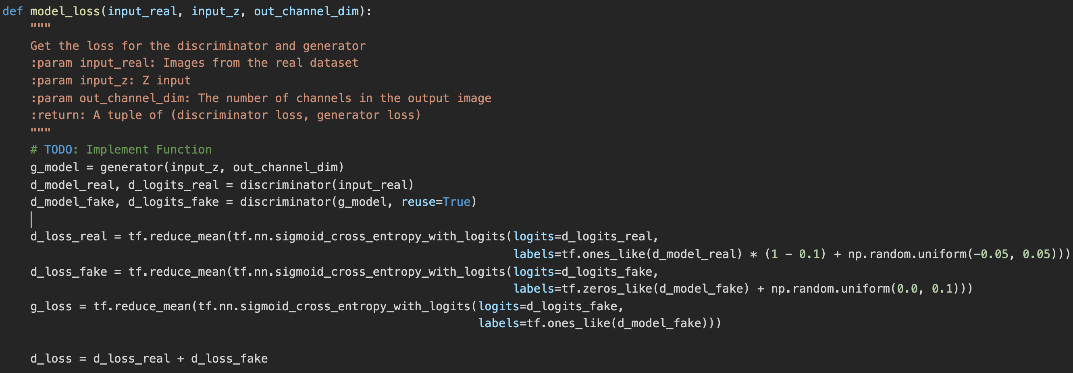

Optimizer:

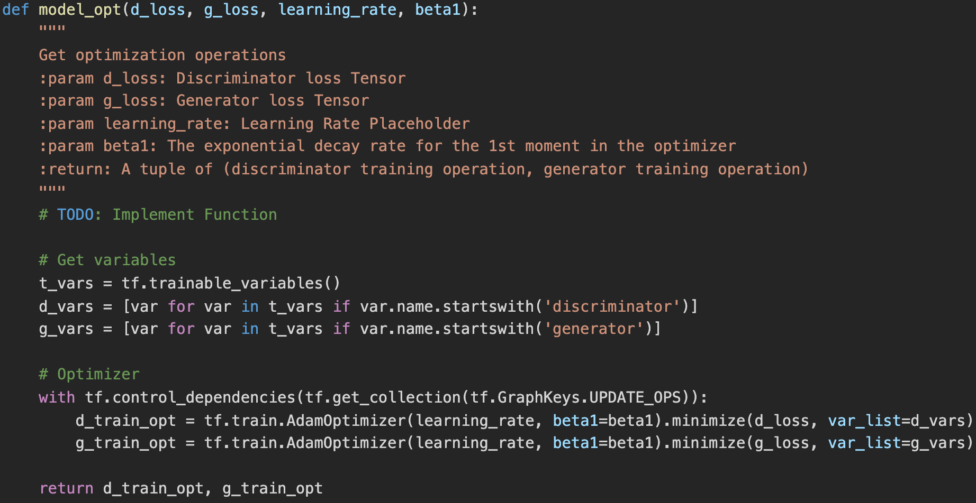

**3.3 Training & Evaluation**

3.3.1 MNIST – Hand Witten Digits Dataset

I used the MNIST dataset for digits generation.

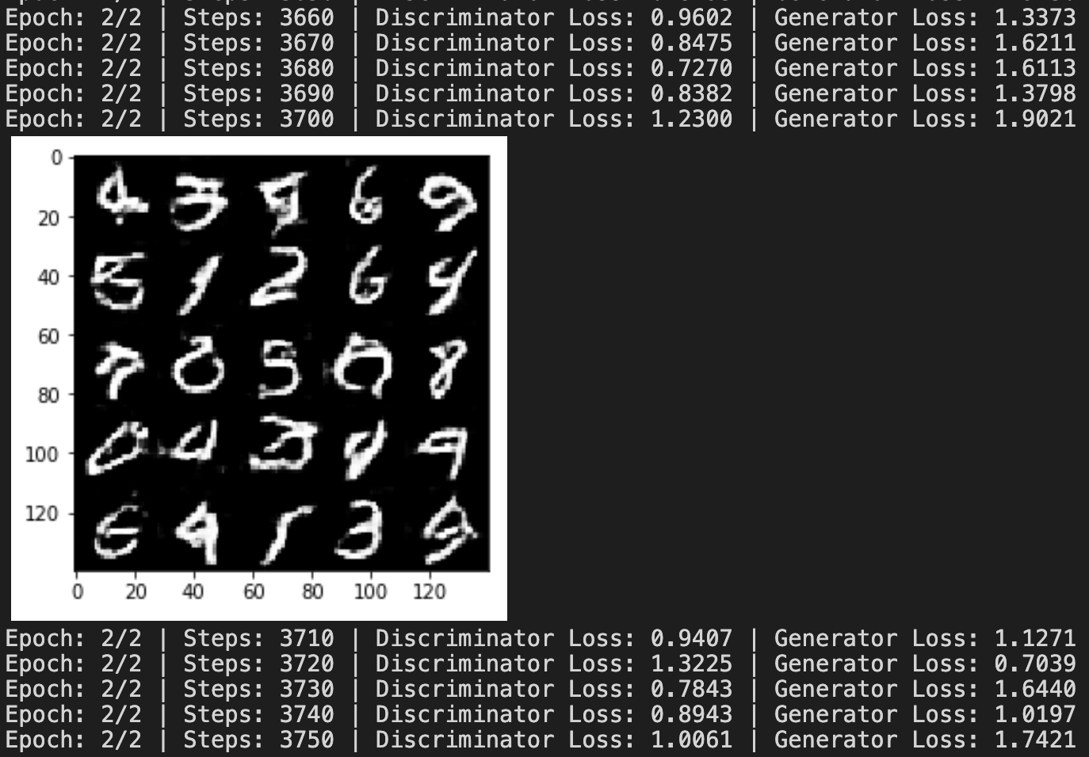

3.3.2 CelebA – Human Faces Dataset

I used the CelebA dataset for face generation. It took around 20 minutes on my GPU server to run one epoch.

